

**UNIVERSITAS BAKTI INDONESIA**

**FAKULTAS ILMU KESEHATAN**

1. S-1 ILMU KEPERAWATAN
2. D-3 KEBIDANAN
3. PROFESI (NERS)

**IJIN SK MENDIKNAS**

**NO. 32/D/O/2009**

1. FAKULTAS KESEHATAN MASYARAKAT
2. FAKULTAS ILMU KESEHATAN
3. FAKULTAS HUKUM
4. FAKULTAS EKONOMI
5. FAKULTAS TEKNIK
6. FAKULTAS BAHASA
7. FAKULTAS MIPA
8. F. KEGURUAN ILMU PENDIDIKAN

**(KawasanKampusTerpadu) BumiCempokosari No.40 Cluring – Banyuwangi (68482); Telp&Fax: 0333-392720**

**DAFTAR HADIR MAHASISWA**

**PROGRAM STUDI DE KEBIDANAN FAKULTAS ILMU KESEHATAN**

**UNIVERSITAS BAKTI INDONESIA**

**MATA KULIAH : FARMAKOLOGI TAHUN AKADEMIK : 2022/2023**

**DOSEN PENGAMPU : Ulva Hari Andini, S.Tr.Keb,. M.Kes SEMESTER : 2**

|  |  |  |  |  |  |  |  |  |  |  |  |  |
| --- | --- | --- | --- | --- | --- | --- | --- | --- | --- | --- | --- | --- |
| **NO** | **NIM** | **NAMA** | **PERTEMUAN** | | | | | | | | **KET** | |
| 29 Mar 2023 | 05 Apr 2023 | 12 Apr 2023 | 19 Apr 2023 | 26 Apr 2023 | 03 Mei 2023 | 10 Mei 2023 | 17 Mei 2023 |
| 1 | 2215401000010 | ALBAQIATUS SHALIHAH |  |  |  |  |  |  |  |  |  |
| 2 | 221540100001 | ARLINA LAOWO |  |  |  |  |  |  |  |  |  |
| 3 | 221540100004 | ENJELIKA LUTU |  |  |  |  |  |  |  |  |  |
| 4 | 221540100002 | NAJJAH FAHILLAH |  |  |  |  |  |  |  |  |  |
| 5 | 221540100003 | SAFARINA AINUL IZZAH |  |  |  |  |  |  |  |  |  |
| 6 | 221540100005 | VALZA KAMELIA RIZKI |  |  |  |  |  |  |  |  |  |
| 7 | 221540100006 | WADIFATUL HASANAH |  |  |  |  |  |  |  |  |  |

|  |  |  |  |  |  |  |  |  |  |  |  |
| --- | --- | --- | --- | --- | --- | --- | --- | --- | --- | --- | --- |
| **NO** | **NIM** | **NAMA** | **PERTEMUAN** | | | | | | | | **KET** |
| 24 Mei 2023 | 7 Jun 2023 | 14 Jun 2023 | 21 Jun 2023 | 28 Jun 2023 | 05 Jul 2023 | 12 Jul 2023 | 26 Juli 2023 |
| 1 | 2215401000010 | ALBAQIATUS SHALIHAH |  |  |  |  |  |  |  |  |  |
| 2 | 221540100001 | ARLINA LAOWO |  |  |  |  |  |  |  |  |  |
| 3 | 221540100004 | ENJELIKA LUTU |  |  |  |  |  |  |  |  |  |
| 4 | 221540100002 | NAJJAH FAHILLAH |  |  |  |  |  |  |  |  |  |
| 5 | 221540100003 | SAFARINA AINUL IZZAH |  |  |  |  |  |  |  |  |  |
| 6 | 221540100005 | VALZA KAMELIA RIZKI |  |  |  |  |  |  |  |  |  |
| 7 | 221540100006 | WADIFATUL HASANAH |  |  |  |  |  |  |  |  |  |

Banyuwangi, 28 Juli 2023

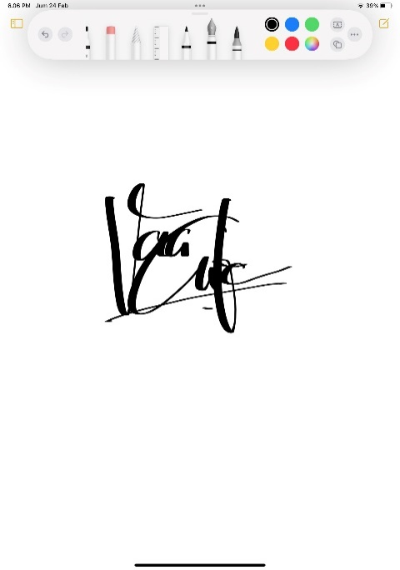Dosen Pengampu

**Ulva Hari Andini, S.Tr.Keb,. M.Kes**

NIDN: 0722039504